**Create Spring MVC Project**

On the Eclipse, create a Spring MVC project

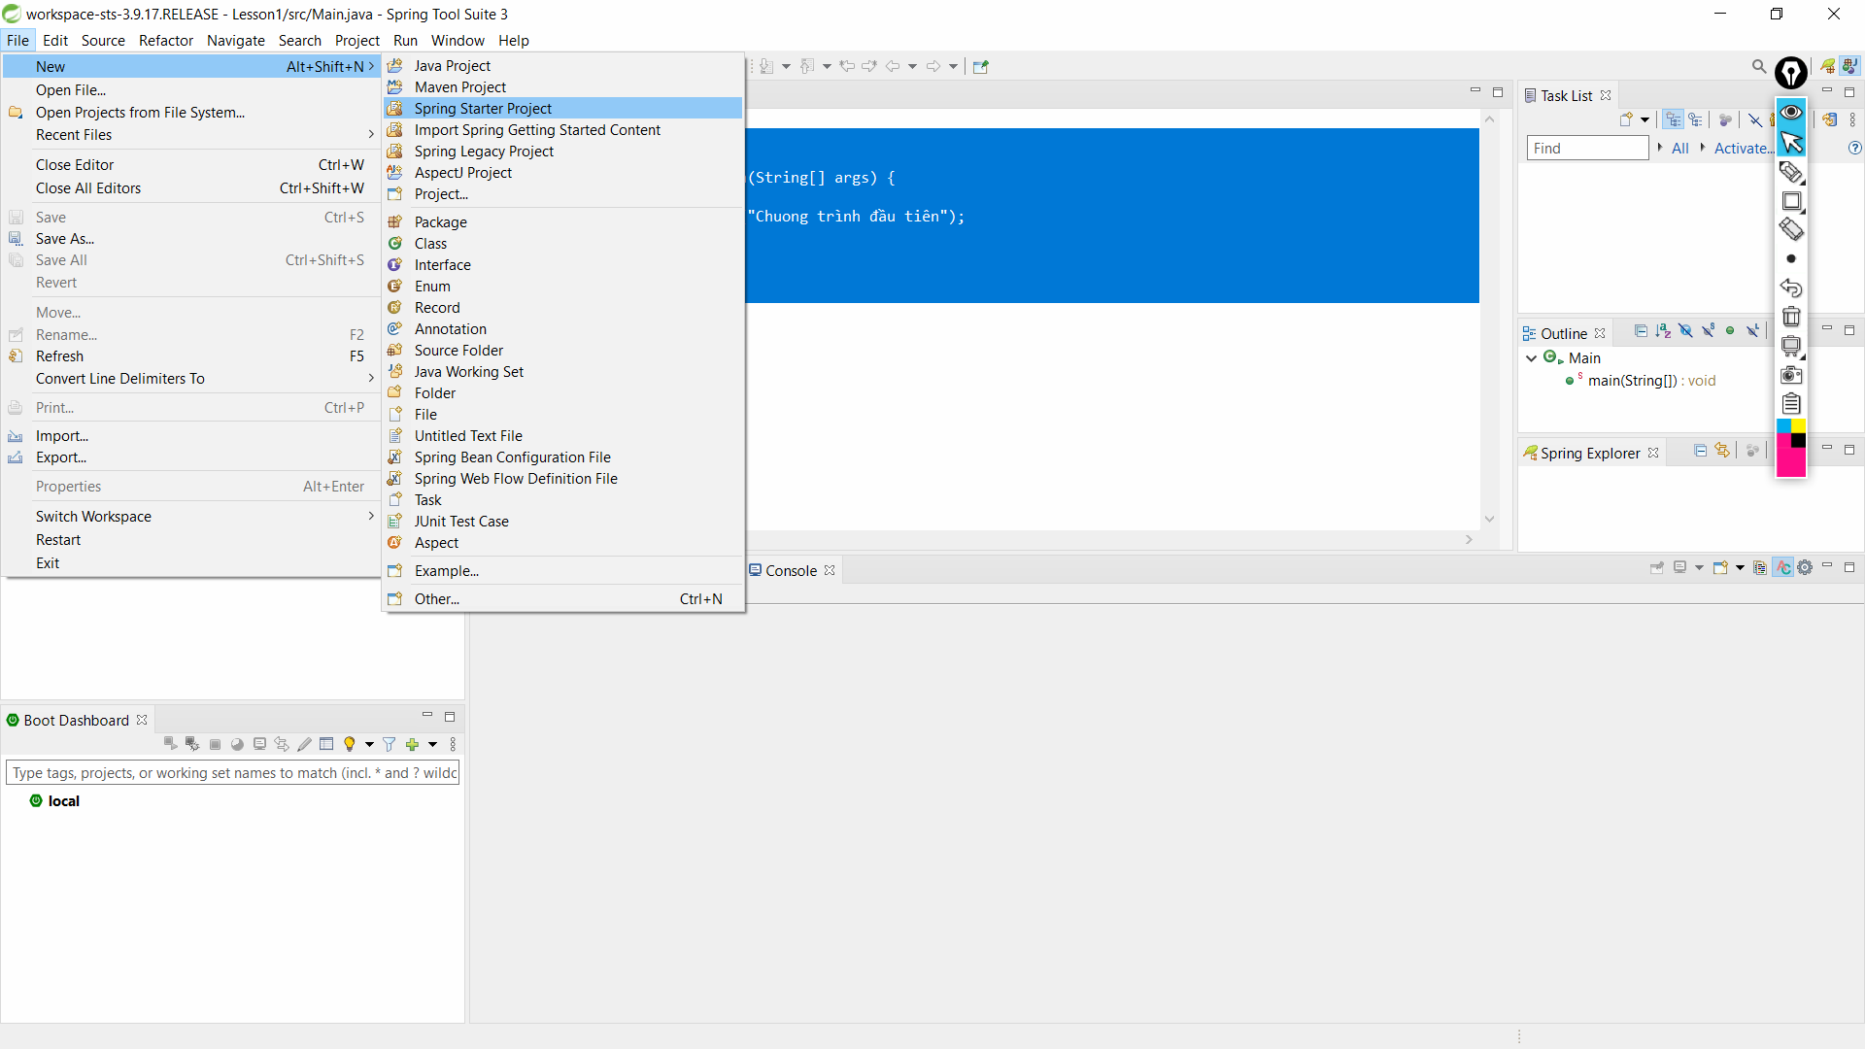

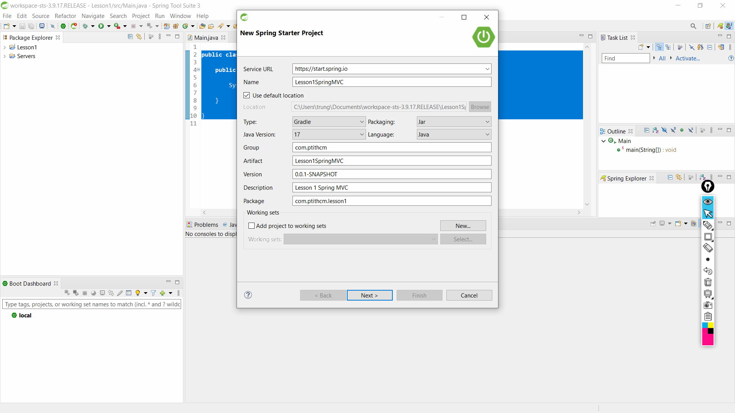

**Enter Project Information:**

Name: Lesson1SpringMVC

Group: com.ptithcm

Artifact: Lesson1SpringMVC

Description: Example 2 Spring MVC

Package: com.ptithcm.example2

**Select the technologies and libraries to be used:**

Web

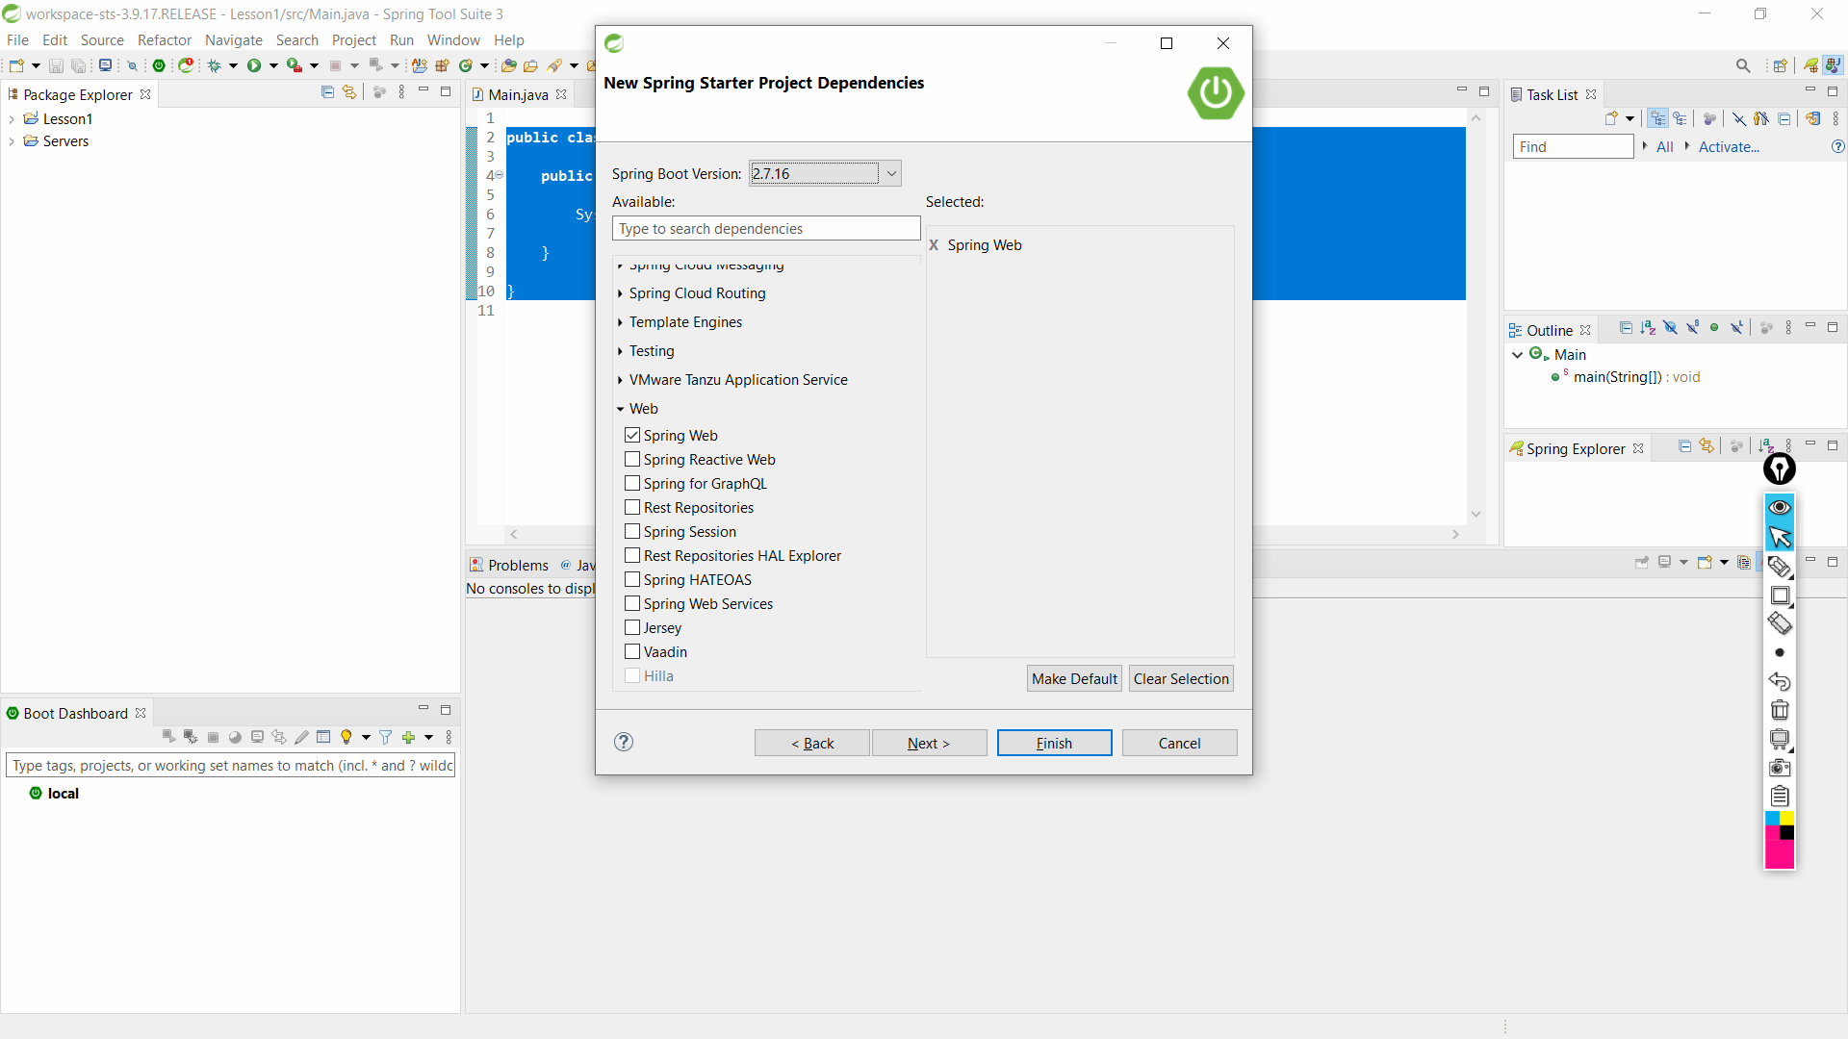

Click Next button to show Site Information for project

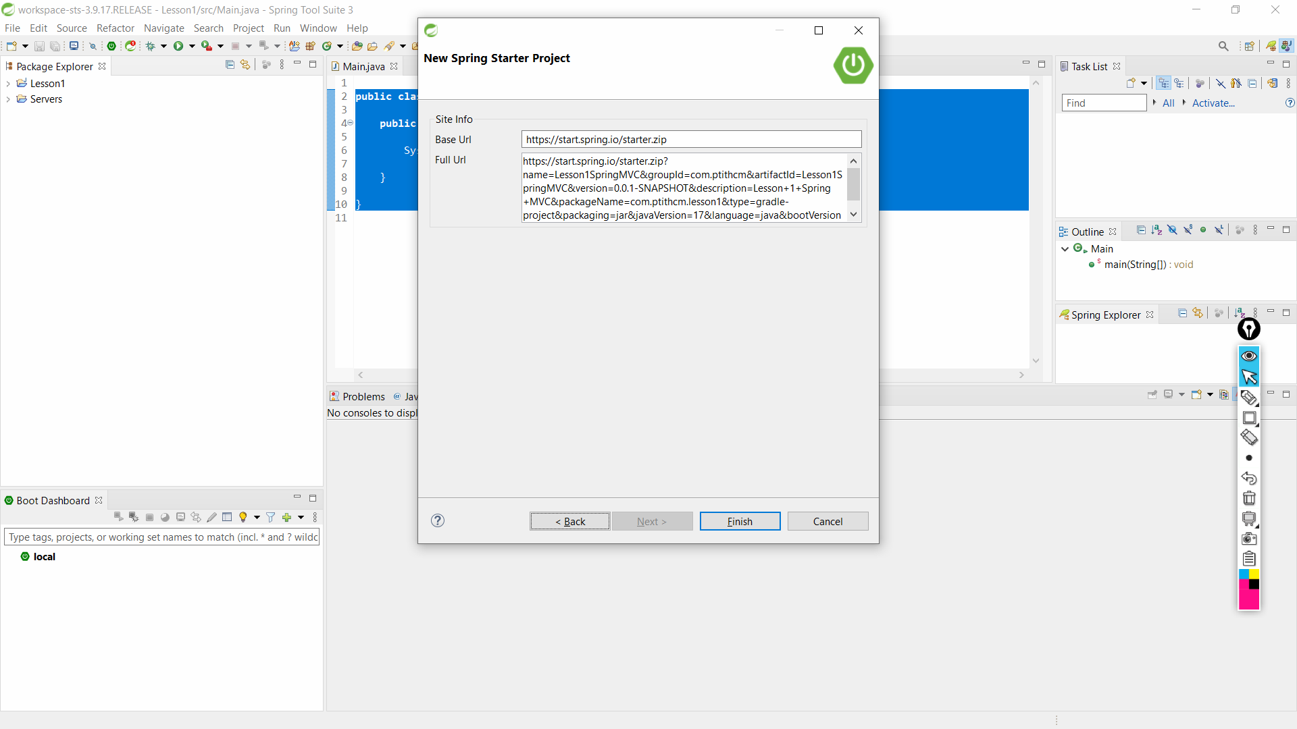

Click Finish button to finish create Spring MVC project

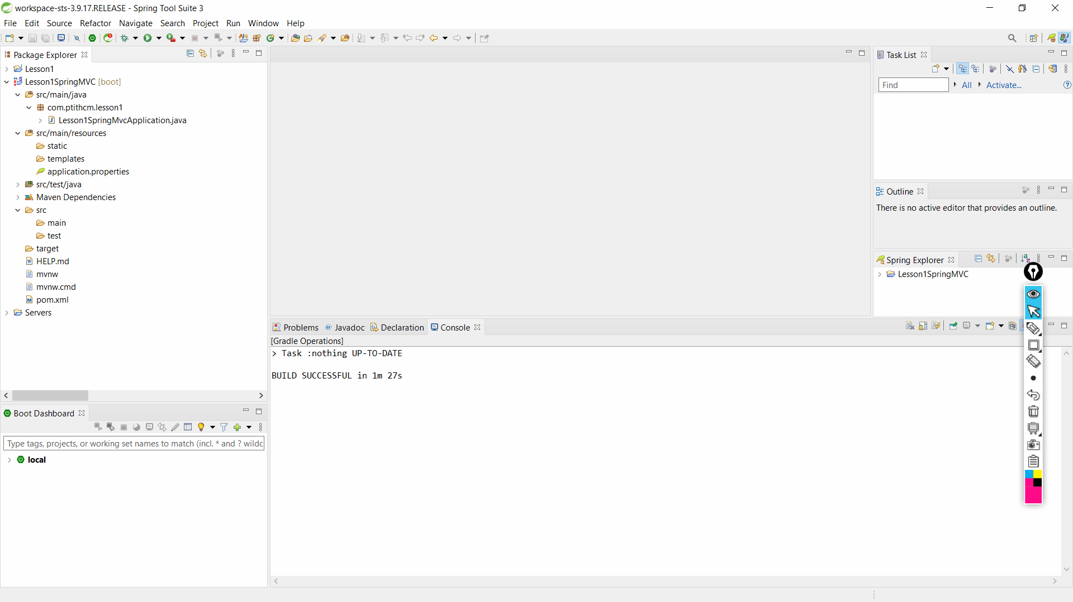

**Configure pom.xml**

<?xml version="1.0" encoding="UTF-8"?>

<project xmlns="http://maven.apache.org/POM/4.0.0" xmlns:xsi="http://www.w3.org/2001/XMLSchema-instance"

xsi:schemaLocation="http://maven.apache.org/POM/4.0.0

http://maven.apache.org/xsd/maven-4.0.0.xsd">

<modelVersion>4.0.0</modelVersion>

<groupId>com.demo</groupId>

<artifactId>LearnSpringMVCWithRealApps</artifactId>

<version>0.0.1-SNAPSHOT</version>

<packaging>jar</packaging>

<name>LearnSpringMVCWithRealApps</name>

<description>Learn Spring MVC with Real Apps</description>

<parent>

<groupId>org.springframework.boot</groupId>

<artifactId>spring-boot-starter-parent</artifactId>

<version>1.5.2.RELEASE</version>

<relativePath /> <!-- lookup parent from repository -->

</parent>

<properties>

<project.build.sourceEncoding>UTF-8</project.build.sourceEncoding>

<project.reporting.outputEncoding>UTF-8</project.reporting.outputEncoding>

<java.version>1.8</java.version>

</properties>

<dependencies>

<!-- Spring MVC -->

<dependency>

<groupId>org.springframework.boot</groupId>

<artifactId>spring-boot-starter-web</artifactId>

</dependency>

<!-- JSTL tag lib -->

<dependency>

<groupId>javax.servlet.jsp.jstl</groupId>

<artifactId>javax.servlet.jsp.jstl-api</artifactId>

<version>1.2.1</version>

</dependency>

<dependency>

<groupId>taglibs</groupId>

<artifactId>standard</artifactId>

<version>1.1.2</version>

</dependency>

<!-- Tomcat for JSP rendering -->

<dependency>

<groupId>org.apache.tomcat.embed</groupId>

<artifactId>tomcat-embed-jasper</artifactId>

<scope>provided</scope>

</dependency>

<dependency>

<groupId>org.springframework.boot</groupId>

<artifactId>spring-boot-starter-test</artifactId>

<scope>test</scope>

</dependency>

</dependencies>

<build>

<plugins>

<plugin>

<groupId>org.springframework.boot</groupId>

<artifactId>spring-boot-maven-plugin</artifactId>

</plugin>

</plugins>

</build>

</project>

**Configure application.properties**

1. spring.mvc.view.prefix = /WEB-INF/views/
2. spring.mvc.view.suffix = .jsp
3. spring.mvc.static-path-pattern=/resources/**
4. server.port=9596

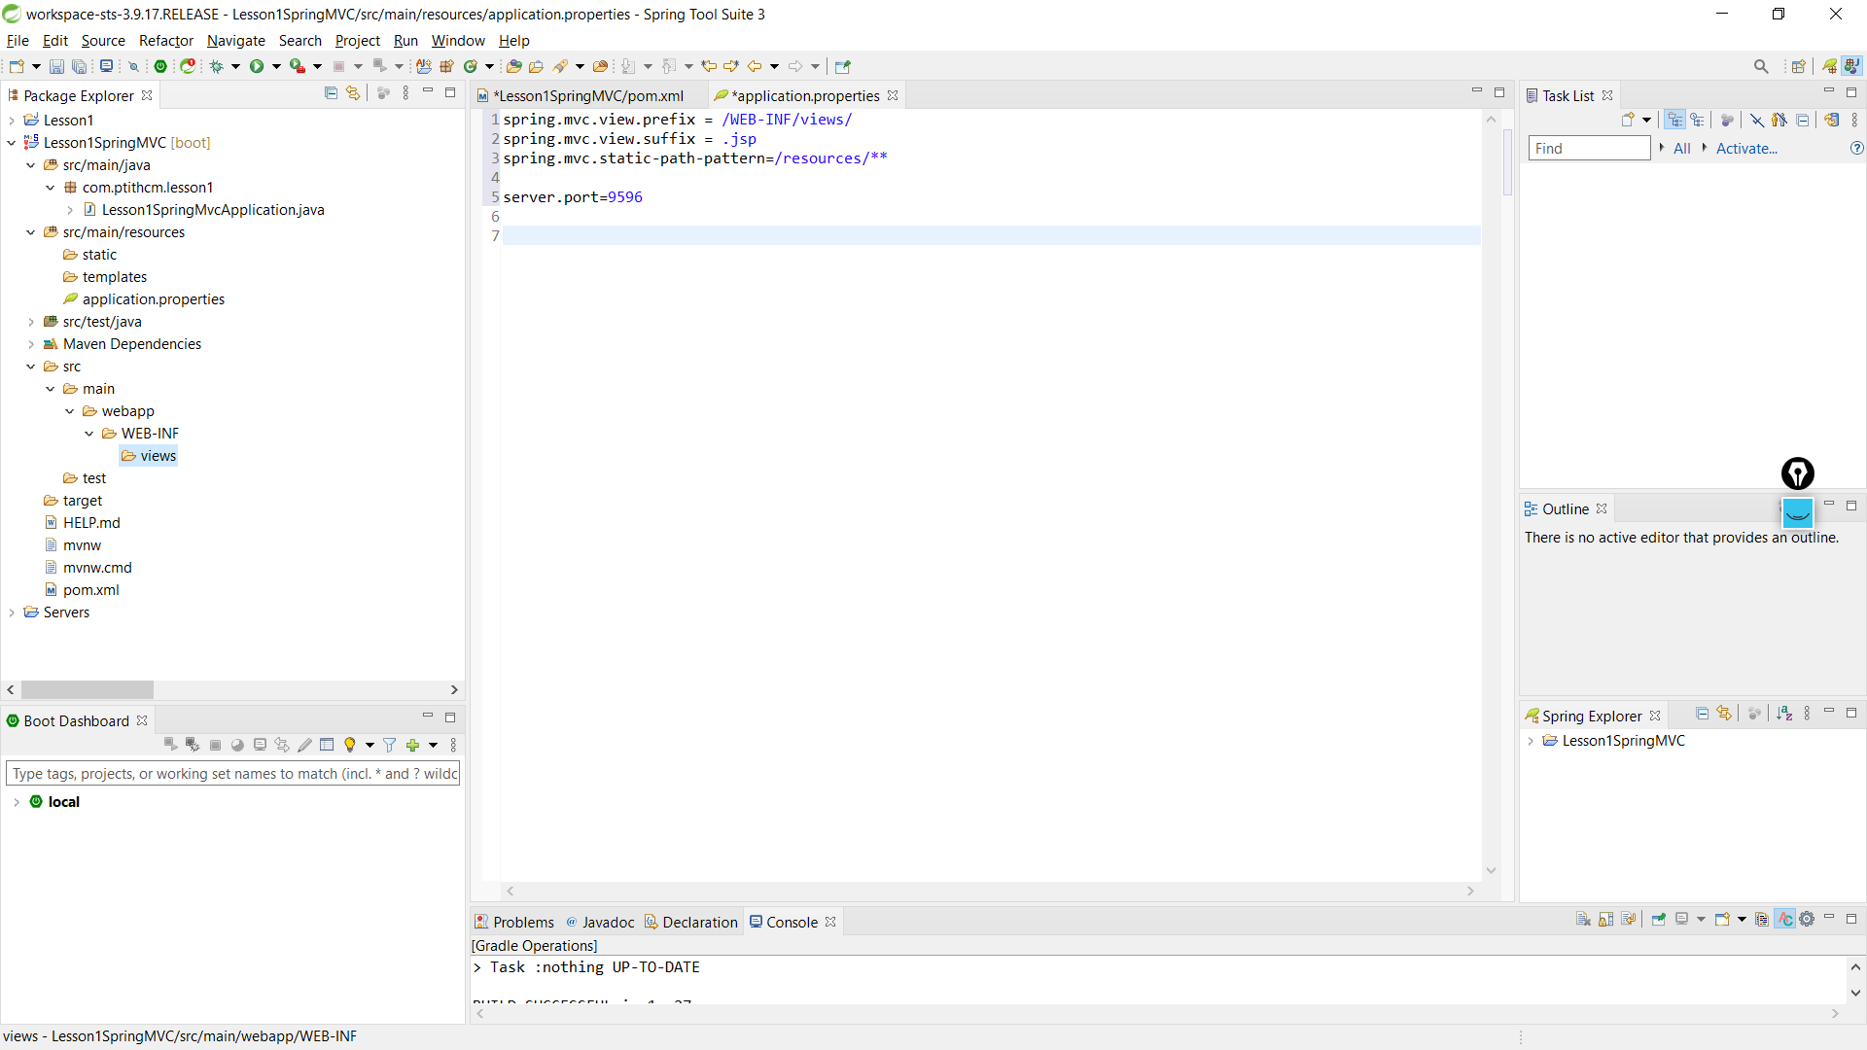

**Create Controller**

Create new package named com.ptithcm.controllers. In this package, create new controller name DemoController as below:

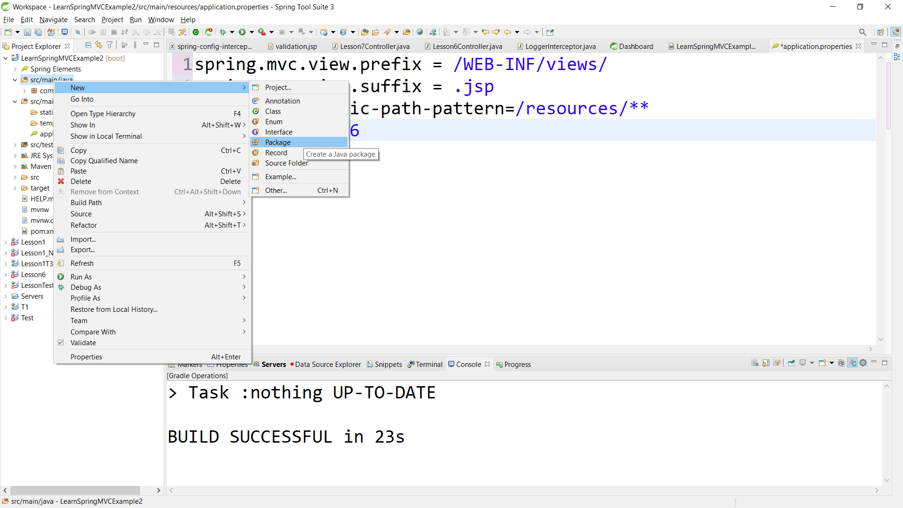

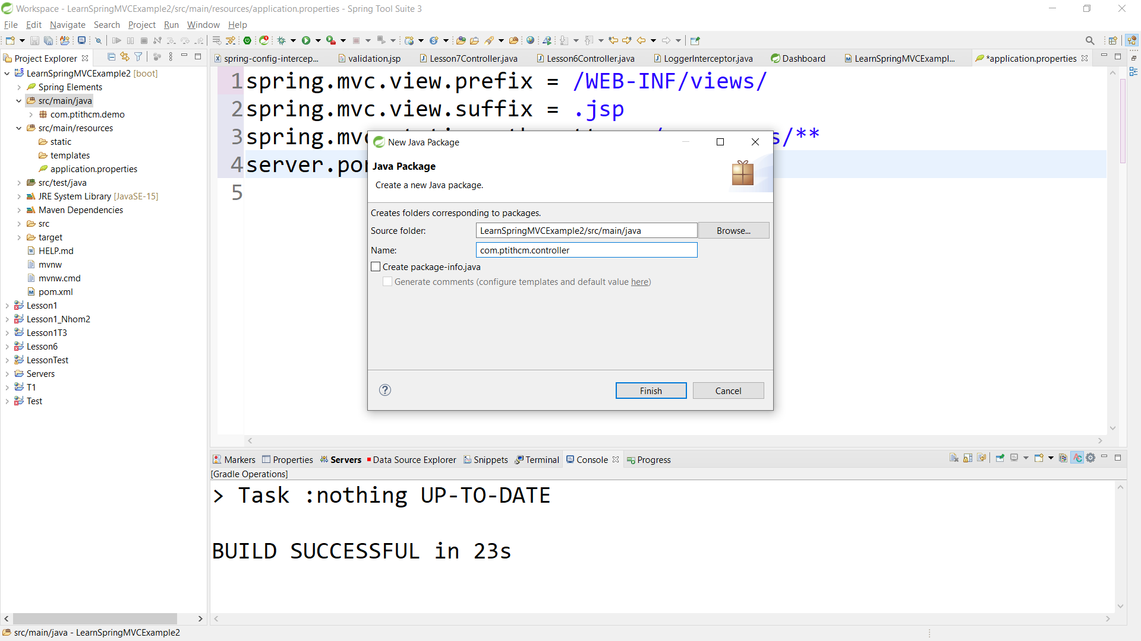

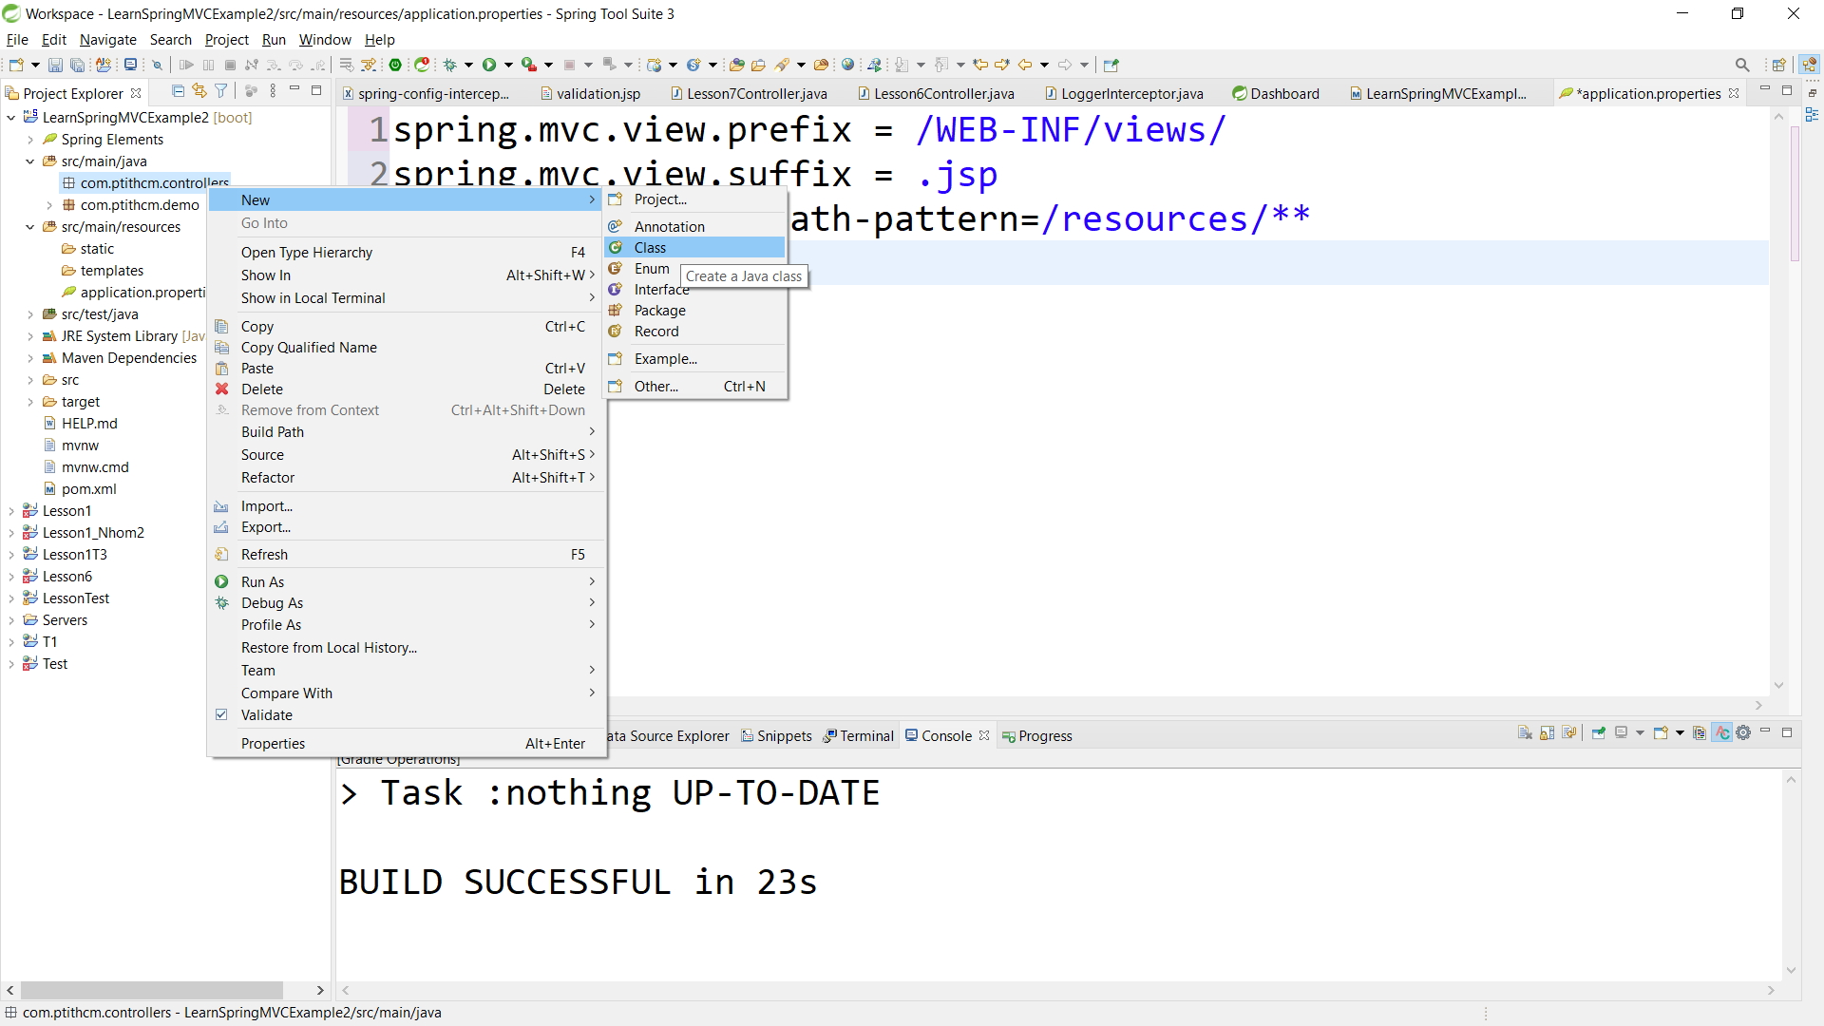

package com.ptithcm.controllers;

import org.springframework.stereotype.Controller;

import org.springframework.ui.ModelMap;

import org.springframework.web.bind.annotation.RequestMapping;

import org.springframework.web.bind.annotation.RequestMethod;

@Controller

@RequestMapping("demo")

public class DemoController {

@RequestMapping(method = RequestMethod.GET)

public String index(ModelMap modelMap) {

modelMap.put("age", 20);

modelMap.put("username", "acc1");

modelMap.put("price", 4.5);

modelMap.put("status", true);

return "demo/index";

}

}

Create View

Create new folders with path webapp\WEB-INF\views in src\main. In views folder, create new folder named demo. In demo folder, create new view named index.jsp as below:

**Index View:**

<%@ page language="java" contentType="text/html; charset=ISO-8859-1"

pageEncoding="ISO-8859-1"%>

<html>

<head>

<meta http-equiv="Content-Type" content="text/html; charset=ISO-8859-1">

<title>Index View</title>

</head>

<body>

<h3>Index View</h3>

Age: ${age }

<br>

Username: ${username }

<br>

Price: ${price }

<br>

Status: ${status }

</body>

</html>

**Structure of Spring MVC Project**

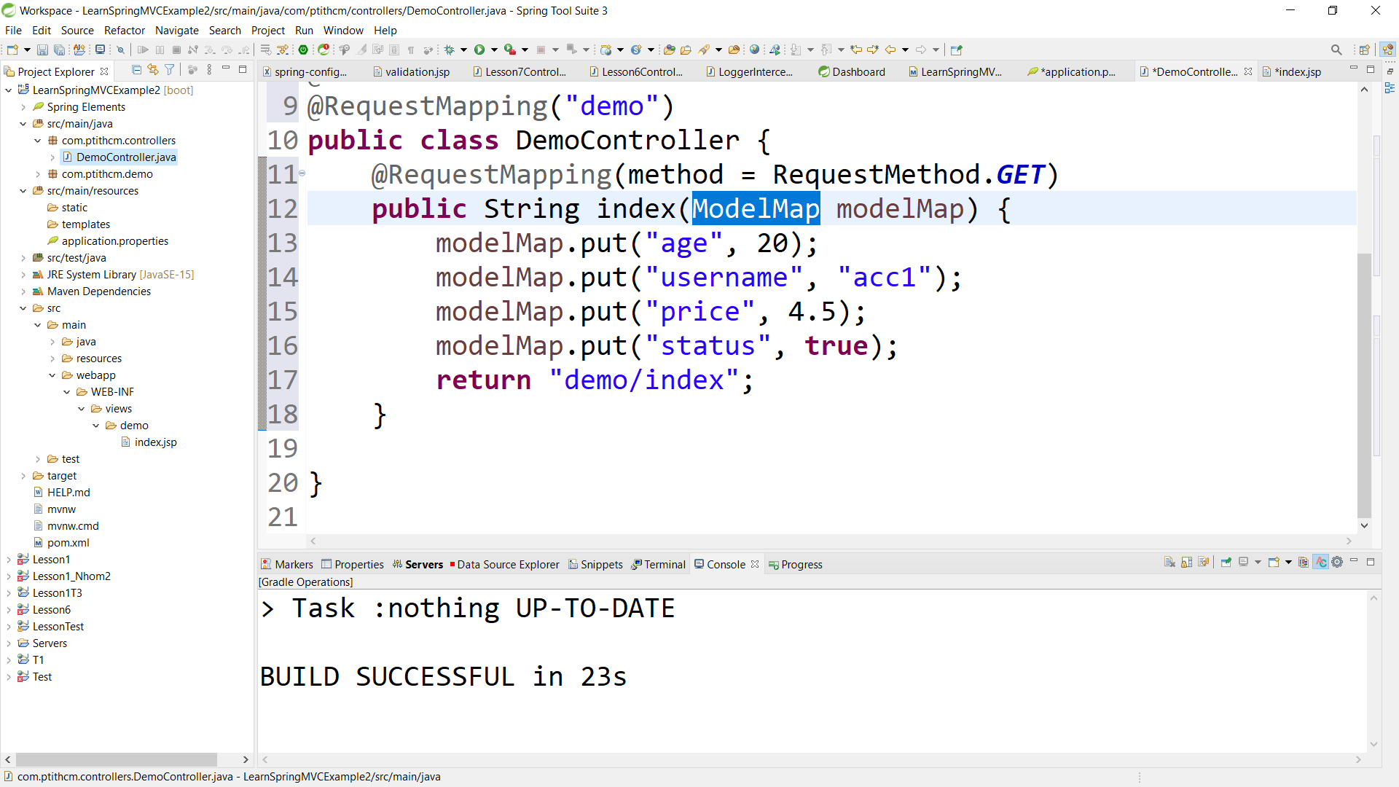

**Run Application**

Select **LearnSpringMvcExample2Application** file in **com.ptithcm.demo** package, right click and select Run As/Spring Boot App menu

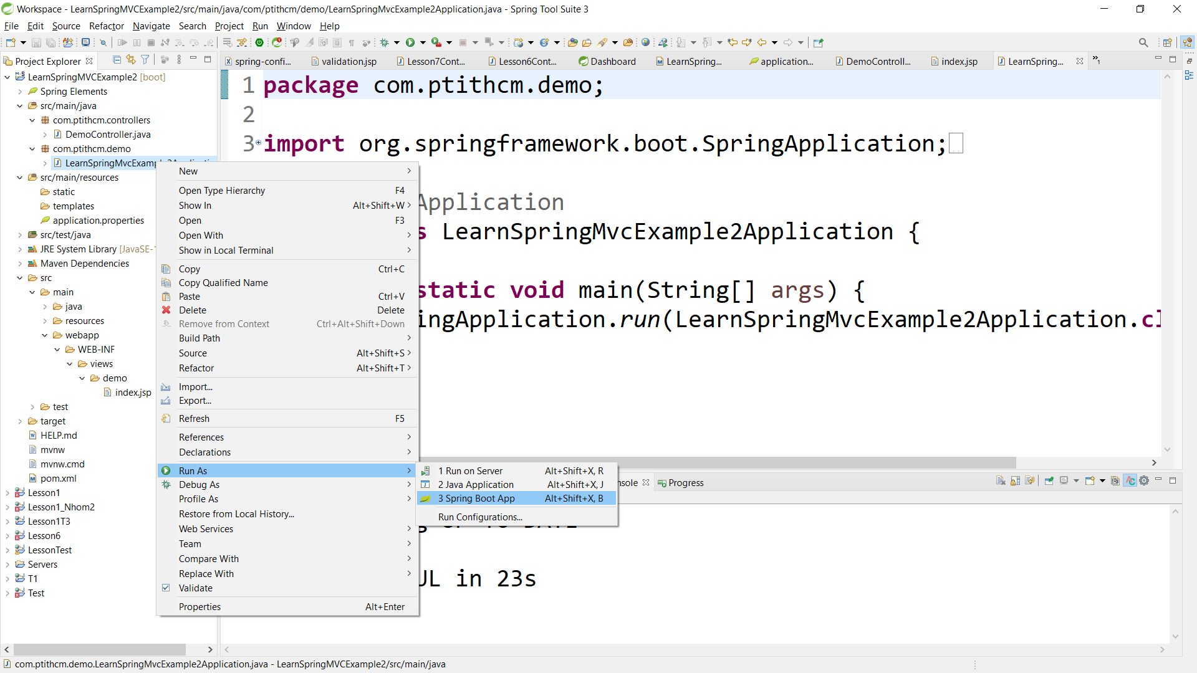

Access index method in demo controller with following url: http://localhost:9596/demo

Output